**TRACING THE GROWTH OF THE GLOBAL COMMUNITY : A POPULATION FORECASTING ANALYSIS**

**Team leader:**

**J.SOUNDARIYA**

**TEAM MEMBERS :**

1. **M.SHANMATHI**
2. **R.PAVITHRA**
3. **M.RAJA RAJESWARI**

**MENTOR: S.VIDHYA**

**1.INTRODUCTION**

* 1. overview

The world’s population is more than three times larger than it was in the mid twentieth century. The global human population reached 8.0 billion in mid November 2022 from an estimated 2.5 on people on 1950, the dramatic growth has been driven largely by increasing numbers of people surviving to reproductive age.

* 1. Purpose

A population projection gives a picture Of what the future size and structure of the population by sex and age might look like. It is based on the knowledge Of the past trends, and for the future on the assumption made for three Components : fertility, mortality and migration.

**2.PROBLEM DEFINITION AND DESIGN THINKING**

**2.1** EMPATHY MAP

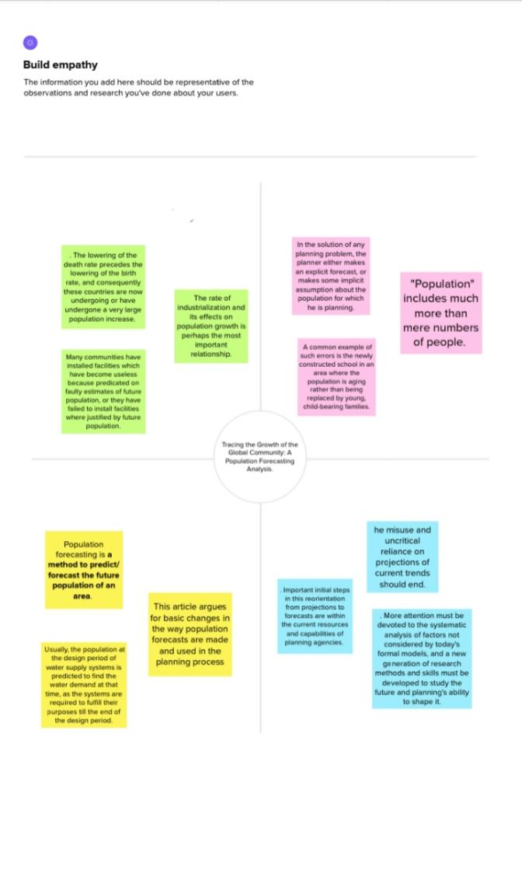

**2.2 Ideation and Brainstorming Map**

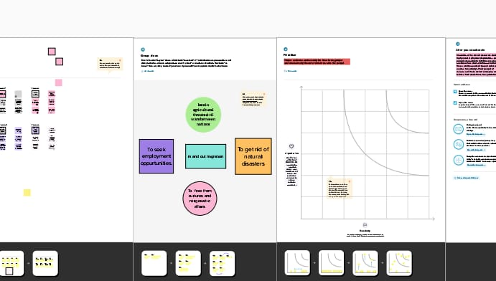

**3.RESULT**

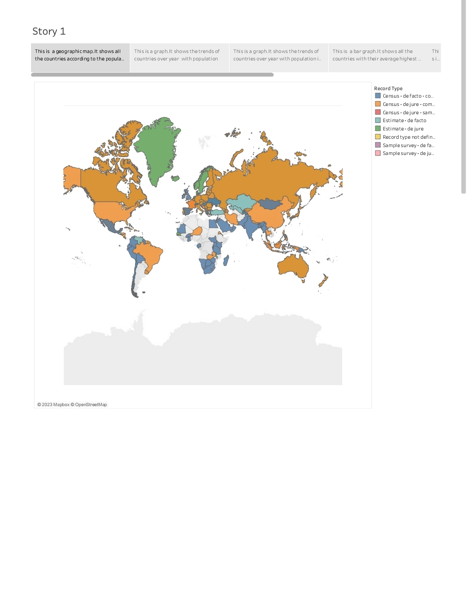

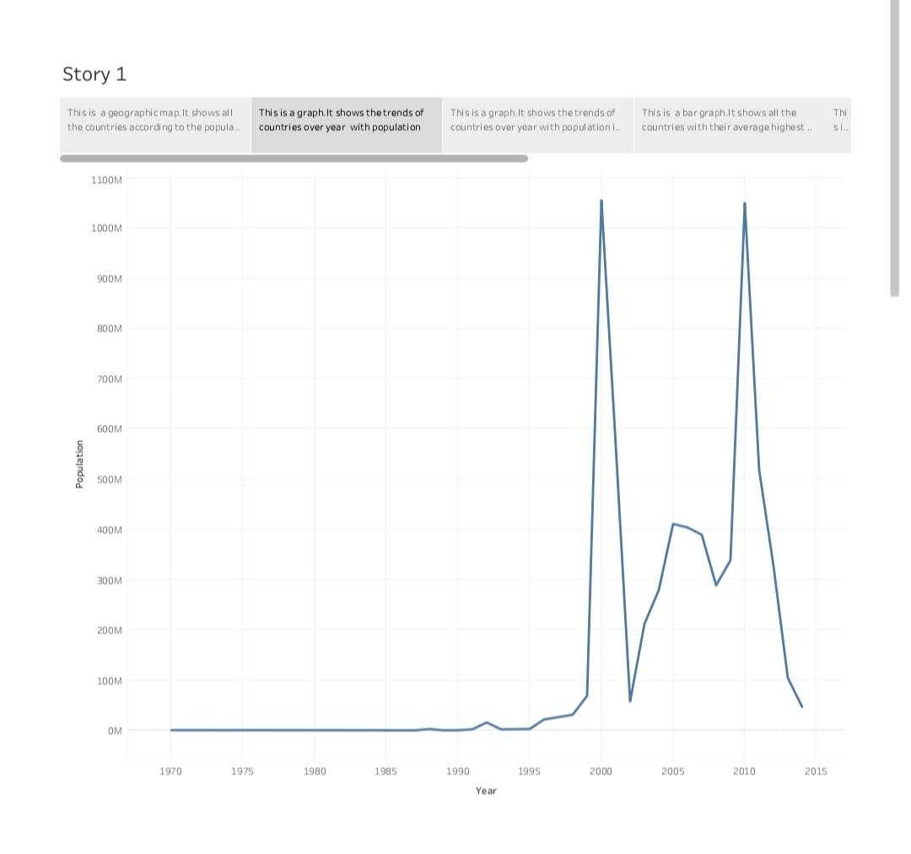

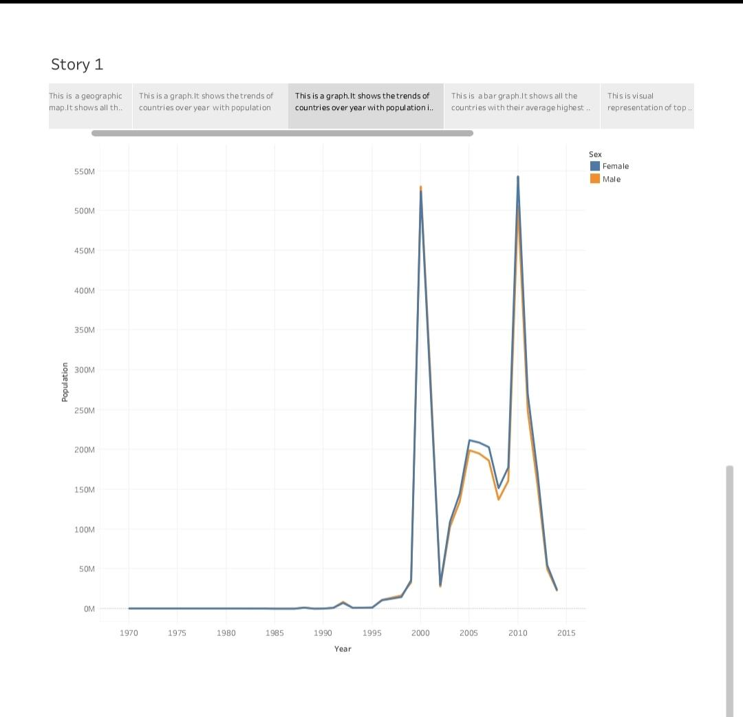

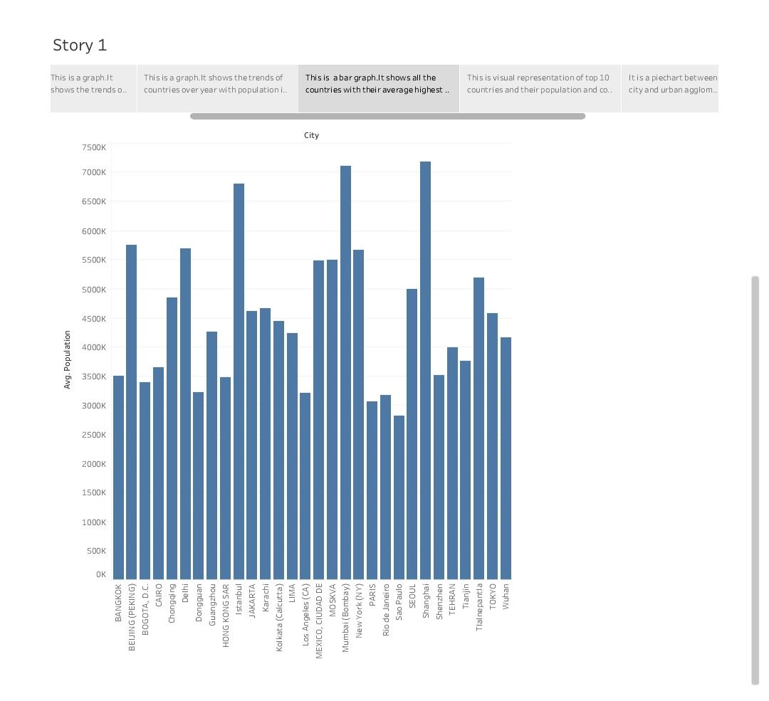

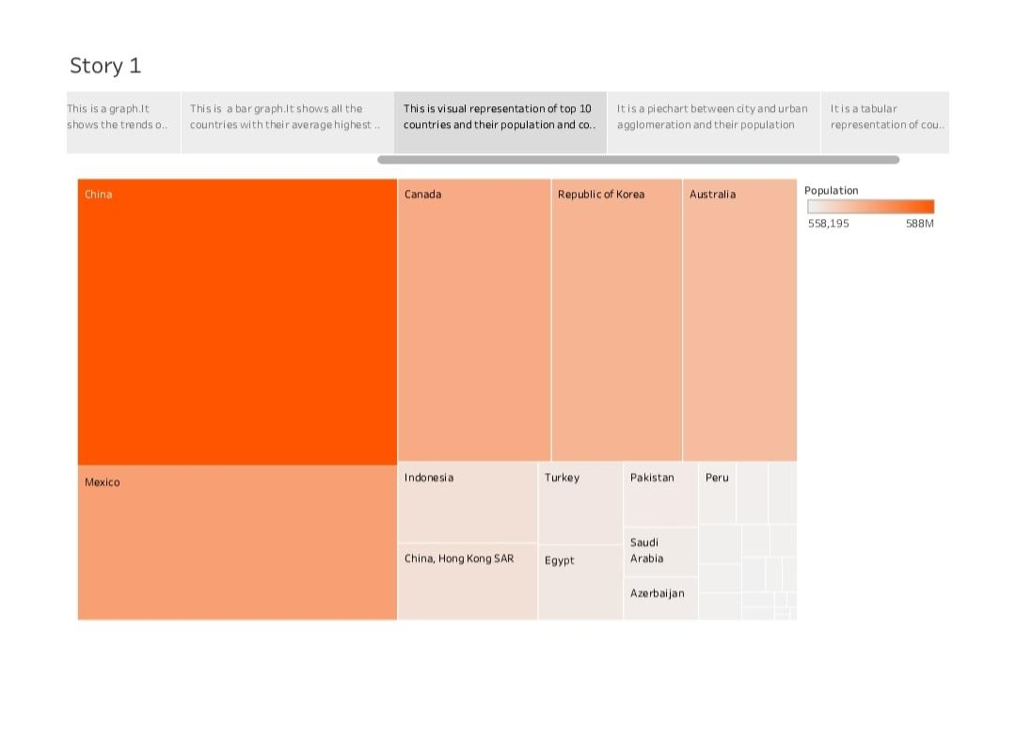

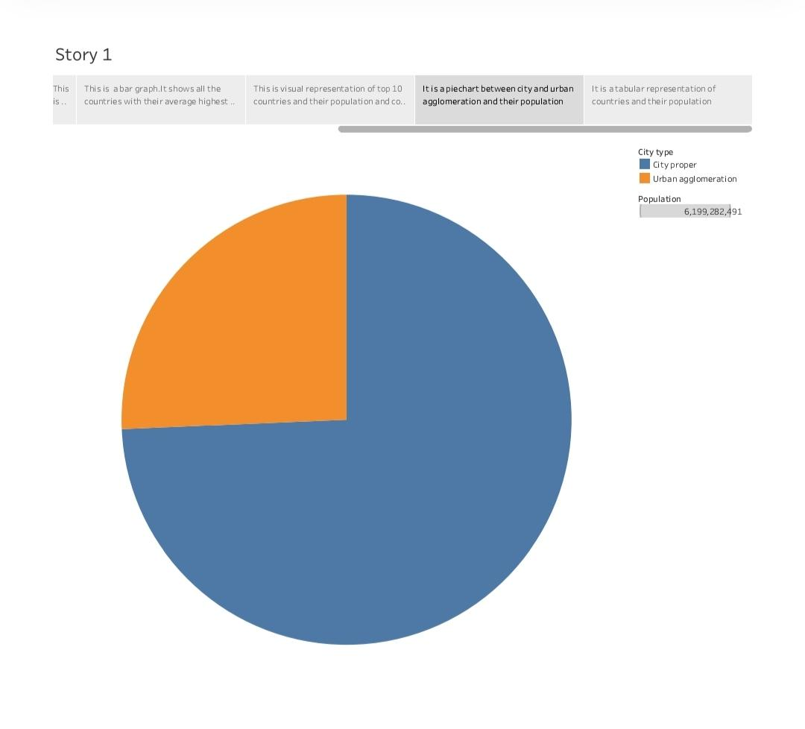

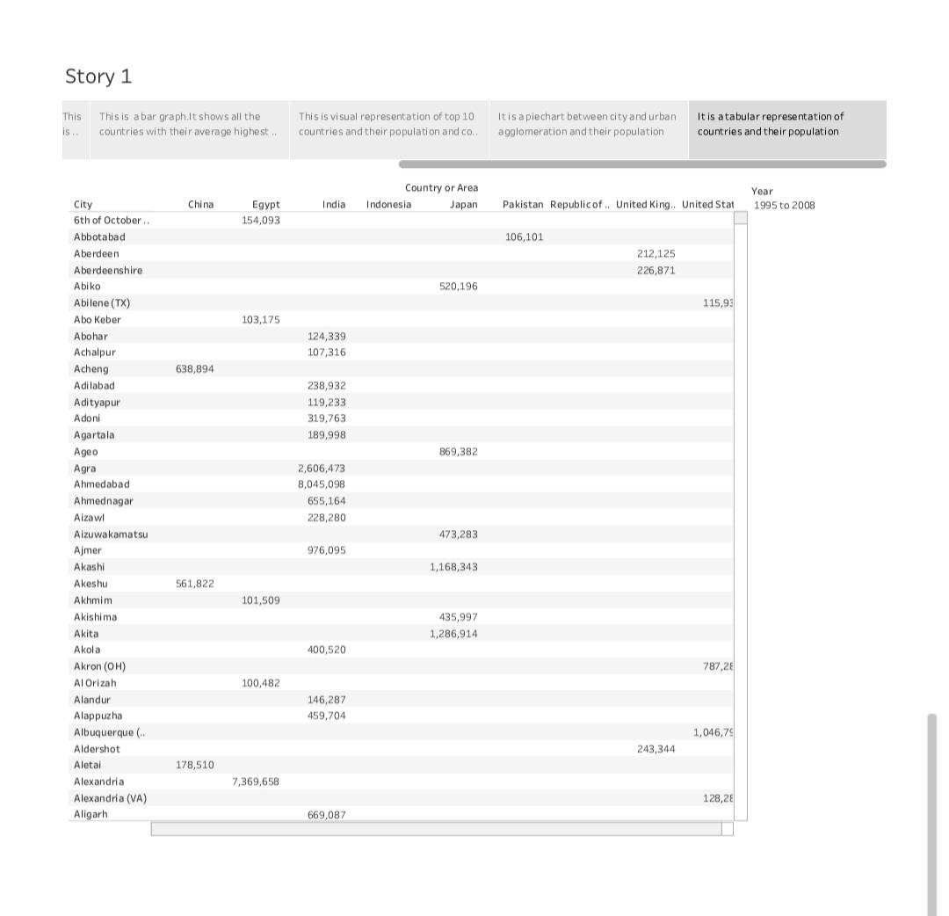

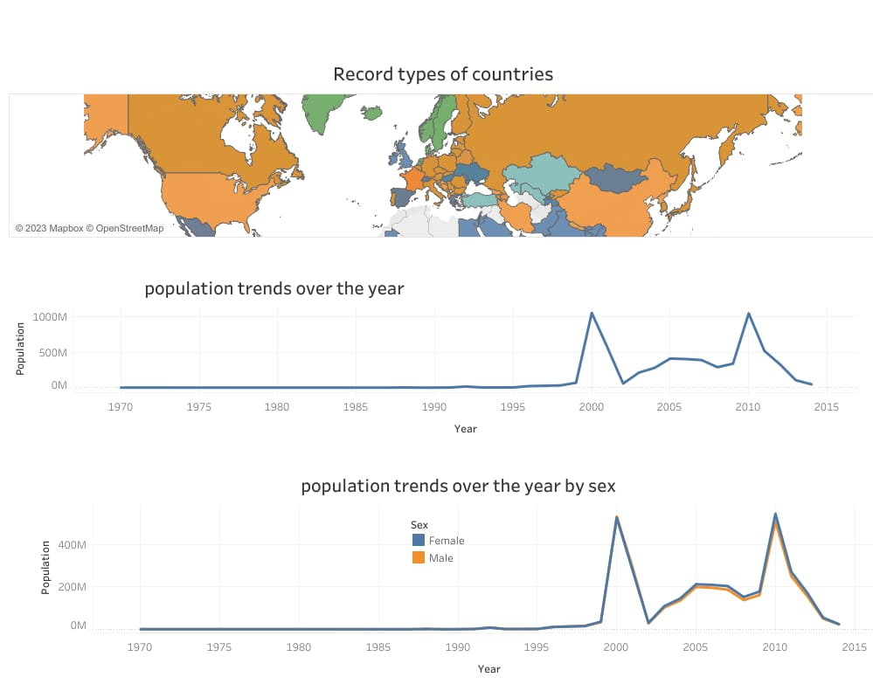

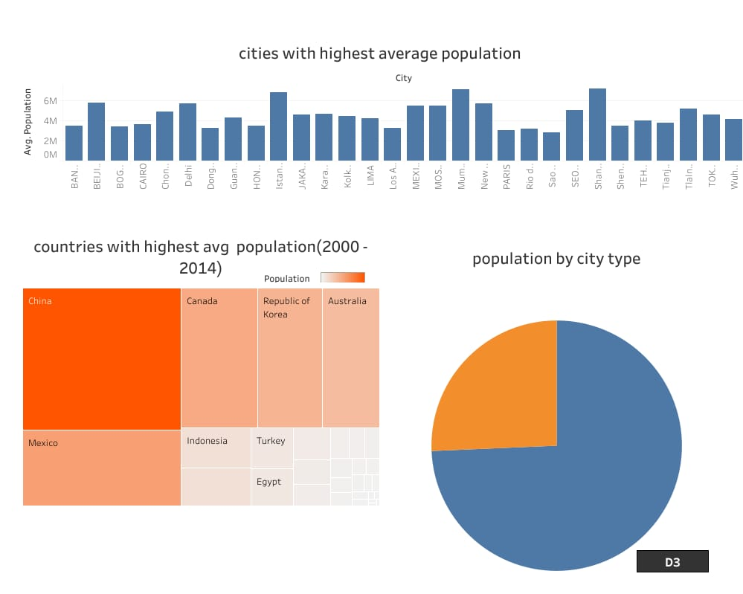

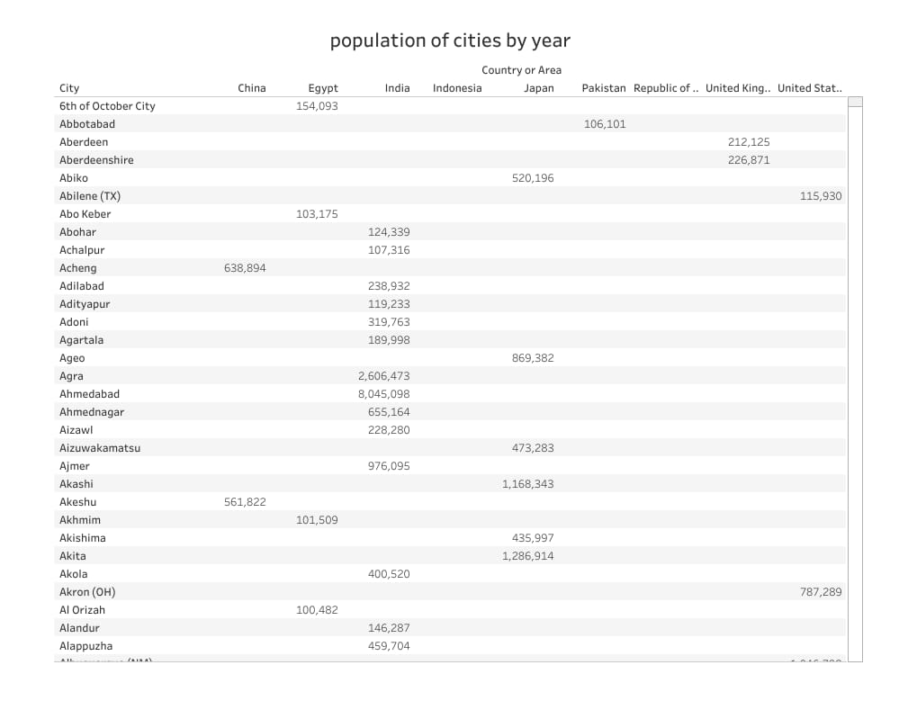

**4. ADVANTAGES AND DISADVANTAGES**

**4.1 Advantages**

* **More people leads to greater human capital.** If there are more people , the probability of finding a genius like Einsterin , Marie Curie , Beethoven increase . These exceptional people

Can lead to technological and culture masterpieces which enrich our lives. The past 200 years have soon exponential growth in technical development and innovation. There are many factors behind this, but the world’s growing population means we have a bigger pool of human capital and the possibility of these cutting edge discoveries increases.

**4.2 Disadvantages**

* **Cost to the environment**

Population growth exacerbates many of the existing environmental problem.

* Trying to reduce Carbon and methane emissions to reduce global warming is relatively more difficult as the population.
* There will be greater threat on Natural habitats as a greater population has greater demand for housing and farmland. This will increase pressure to cut down forests to make way for Farming and housing.

**5. APPLICATIONS**

In the solution of any planning problem, the planner either makes an explicit forecast, or makes some implicit assumption about the population for which he is planning. “Population” includes much more than mere numbers of people. The planner must know what kind of people live in his planning area, what types of lives they will live, and how long they will replace them when they move out or die: how many children they will have, whether these children will live in the area, and many other factors.

Many communities have installed facilities which have become useless because predicated on faulty estimates of future population, or they have failed to install facilities where justified by future population.

**6. CONCLUSION**

Finally, studying population growth gives scientists insight into how organisms interact with each other and with their environments. This is especially meaningful when considering the potential impacts of climate change and other changes in environmental factors .

**7. FUTURE SCOPE**

Population growth is determined by interaction of biotic potential and environmental resistance. Population studies help us to know how far the growth rate of the economy is keeping pace with the growth rate of the population **.**